**An Invitation to Join**

**Carols on the Doorstep**

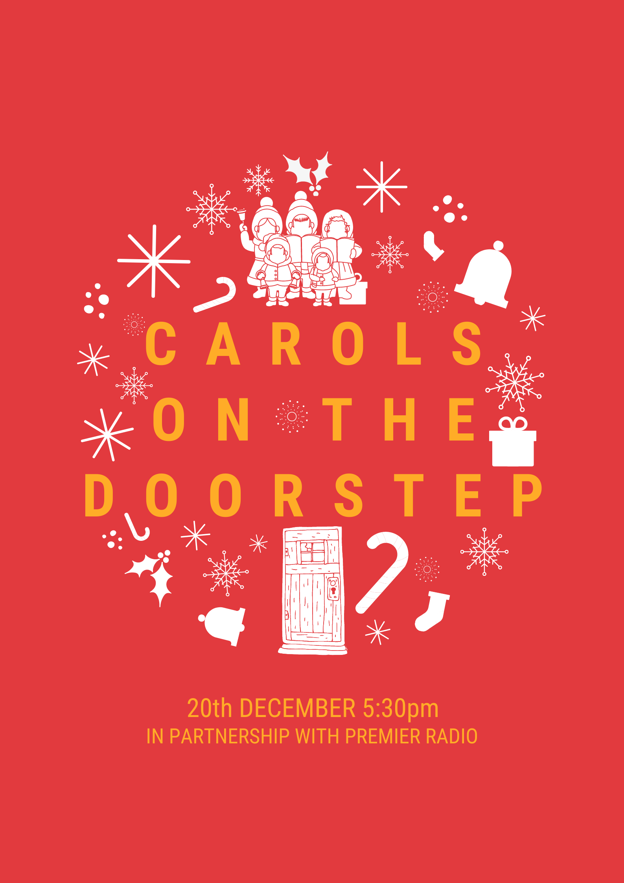

During the run up to Christmas many of us like to go to a Carol Service or Community Carol Singing event, this year we cannot do that but that does not have to stop us having a good sing with our neighbours and our community.

On **Sunday 20th December at 5:30pm** the whole country has the chance to join in Carols on your Doorstep. All you need to do is be able to hear Premier Radio. The easiest way is to turn your TV on to channel 725. (There are alternatives with DAB, Internet and the Premier Radio phone app but be careful about sound lag between all these.) Premier Radio will play 3 or 4 carols for everyone to sing along to. A carol sheet will be posted through your door nearer the time.

This is a good chance to dust off that festive jumper or your most festive headwear if you like. It will be family-friendly so children welcome to bring something to shake or rattle along too.

My name is: and I live at:

I am going to sing on my doorstep and I am inviting you to join me.

At this challenging time for all of us let’s try and bring a little joy to our community this Christmas.

