**An Invitation to Join**

**Carols on the Doorstep**

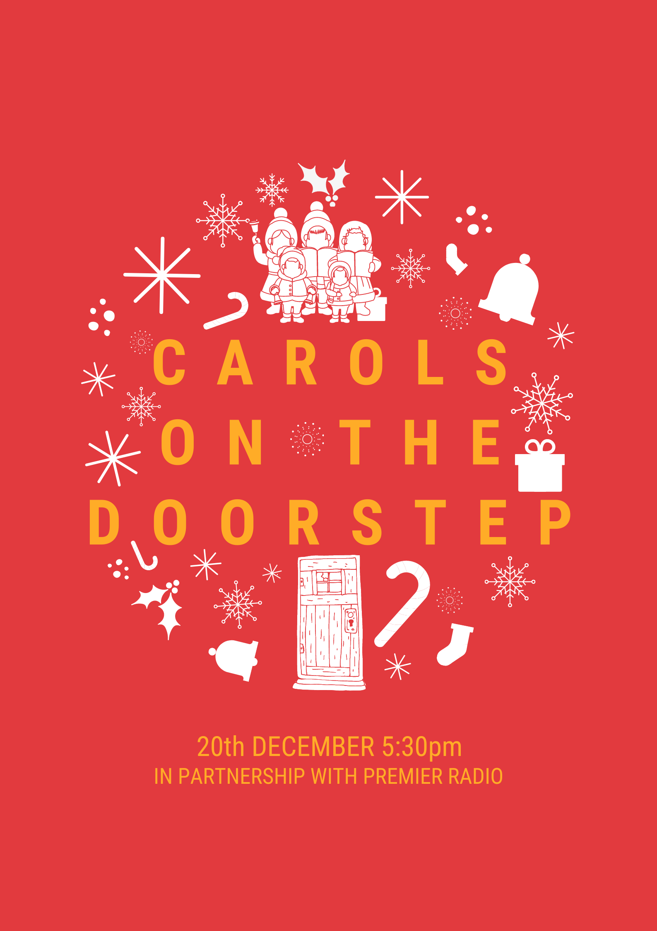

During the run up to Christmas many of us like to go to a Carol Service or Community Carol Singing event, this year we cannot do that but that does not have to stop us having a good sing with our neighbours and our community.

On **Sunday 20th December at 5:30pm** the whole country has the chance to join in Carols on your Doorstep. All you need to do is have a radio at hand. That can be a DAB radio, Freeview on your TV (725) or the Premier Radio phone app. Premier Radio will play 3 or 4 carols for everyone to sing along to. A carol sheet will be posted through your door nearer the time.

This is a good chance to dust off that festive jumper or your most festive headwear if you like. It will be family-friendly so children welcome to bring something to shake or rattle along too.

My name is: and I live at:

I am going to sing on my doorstep and I am inviting you to join me.

At this challenging time for all of us let’s try and bring a little joy to our community this Christmas.

