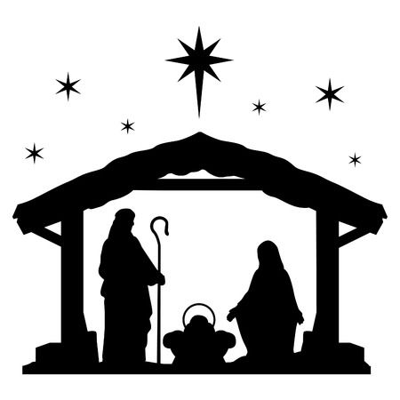

Dear
As we approach Advent and Christmas I offer seasons greetings to you. And your family.
One of the most powerful and recognisable images in the advent and Christmas season is the STABLE. We all know that a good home and a STABLE life are really important. Having a place to call home is essential not only to our physical well-being but also our mental well-being. As they say “Home is where the heart is.” However, for many people at the moment a STABLE life, economically, physically and mentally is not what they are experiencing for a variety of reasons but we know that the effects of the Covid 19 pandemic are adding to the challenges many individuals and families face. We know that due to Covid 19 and the subsequent lockdowns restrictions:
- Around 14 million adults experienced a loss of income
- An estimated 6 million people have fallen behind on one or more household bill
- 1.3 million families are in Council Tax arrears as a direct result of lockdown
- 19% of households borrowed money to buy food or other essentials in July alone.
- 174,000 tenants have are living with the threat of eviction as soon as measures are loosened to stop landlords from being able to evict.
- 227,000 adults in private accommodation have fallen into rent arrears
- 1.5 million more people had to receive State benefits
- Those who are the least qualified and with the lowest income are the most affected financially by lockdown
- While higher earners were able to pay off record amounts of personal debt due to Lockdown, the poorest accrued more debt.
I am supporting a call to #ResetTheDebt for many of those who have accrued debt because of lockdown measures. We are calling on the Chancellor to create a Jubilee Fund (approximately £5bn) to provide grants for the most vulnerable to pay off and cancel their unavoidable debt. This would give the most vulnerable in our society a STABLE platform from which to rebuild and then be in a position to contribute to the growth in the economy going forward so we can build a STABLE economy. It would also contribute to the STABLE life we all need but many are currently denied.
I am sending you this STABLE tree decoration (or card) as a reminder that the Christmas season is a story of hope being born out of poverty. Jesus born in a stable and placed in a manger which would have contained food for the animals. At a time when feeding families is also such a high profile issue this image of Jesus being placed in the feeding trough feels even more pertinent.
I ask that you would actively support this campaign to #ResetTheDebt, urge the Chancellor to create a Jubilee Fund and and provide the hope of a more STABLE future for millions in this country this Christmas.

More information on the campaign can be found at https://resetthedebt.uk

Yours sincerely

